NAME: PRIYADHARSHINI N

REG NO: 731621121043

EMAILID: [priyanarayanan2603@gmail.com](mailto:priyanarayanan2603@gmail.com)

SQL LAB PRACTICE-01

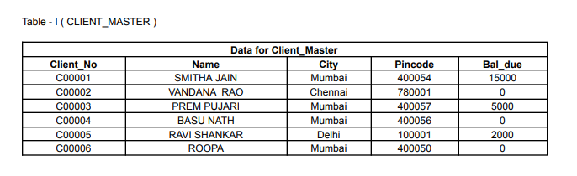

Table Creation:

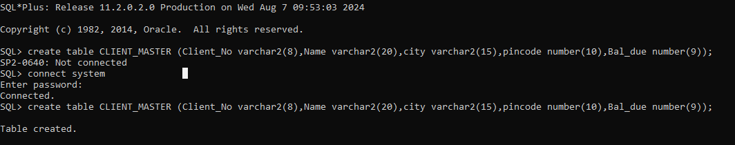

Describe Table:

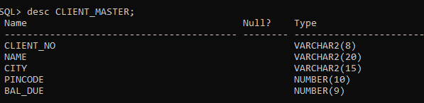

Inserting Values:

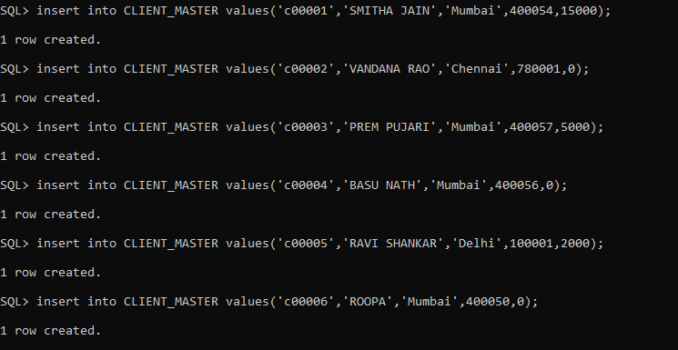

Save the Transaction:



CLIENT_MASTER Table:

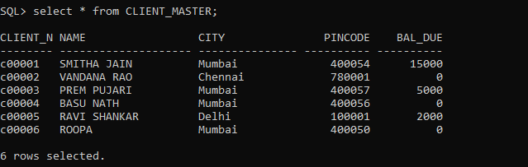

List all details from the client_master table for clients whose Bal_due = 0.

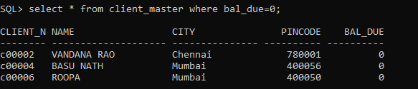

Update table client_master, Change city of Client_no C00004 to Jaipur.

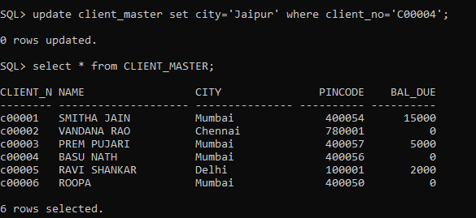

Retrieve records of clients residing in Mumbai.

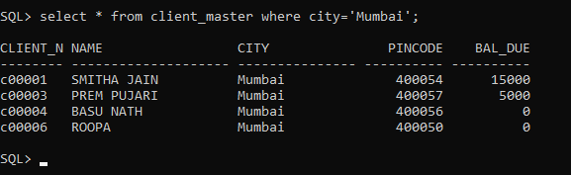

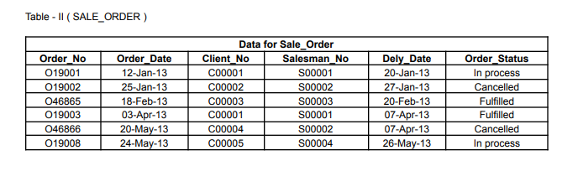

Table Creation:

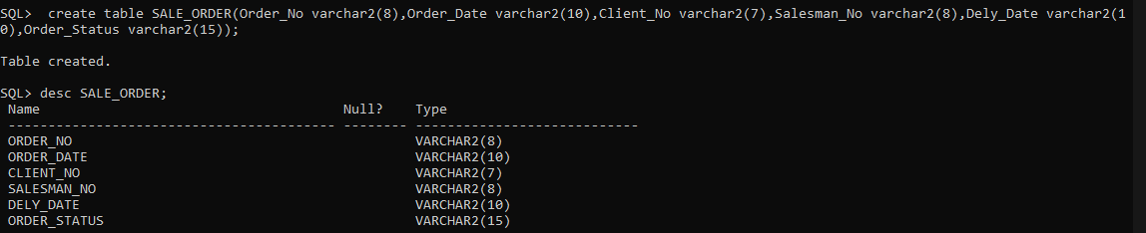

Insert Values:

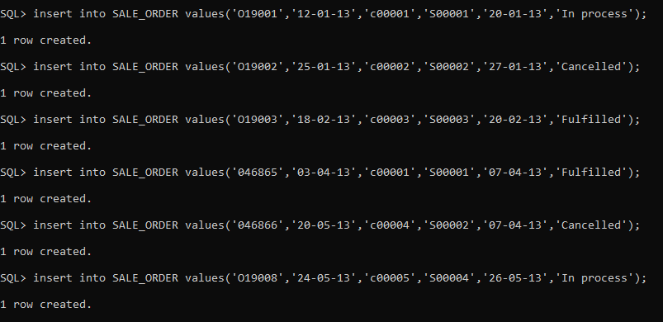Save Changes:



SALE_ORDER Table:

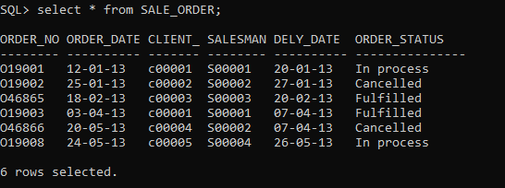

Find the name and address of customer who has placed Order_no 'O19003' and 'O19002'

respectively.

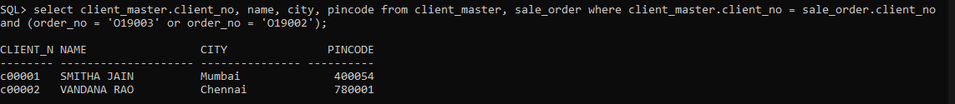

Construct English like sentence from the table client_master ({Customer name} live in the city of {city}).

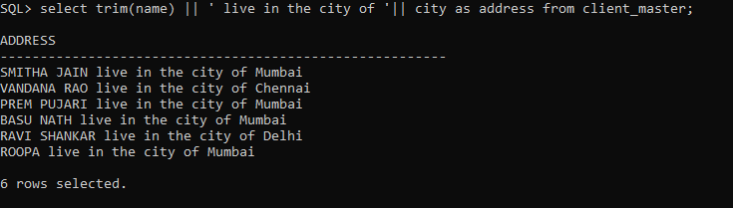

List the client_no, name, city and pincode of clients whose Order_status is "In process".

